AS01 -

Functionality
A fixed asset is defined as an individual economic good that it is recognized in the balance sheet at the time of closing, and is in the long-term service of the enterprise.

In order to make it easier for the user to create, maintain and evaluate master data, the varied individual information is structured according to its area of use and the relevant functions in the system. The asset master record consists of two main parts:

- General Master Data: This part of the master record contains concrete information about the fixed asset.

- Data for Calculating Asset Values: You can specify depreciation terms in the asset master record for each depreciation area in the chart of depreciation. In order for you to make these specifications, the master record contains an overview of the depreciation areas. In addition, there is a detailed display available for each depreciation area. If there are depreciation areas that are not needed for a specific asset, it is possible to deactivate these depreciation areas at the asset level.

Scenario
This system task is used to create an asset master record.

Requirements
A Capital Investment Order with Budget should have been created in preparation for assignment to the asset master record.

Menu Path | Accounting → Financial Accounting → Fixed Assets → Asset → Create → AS01 - Asset
Transaction Code | AS01

1. Double Click on AS01 - Asset

Create Asset: Initial screen

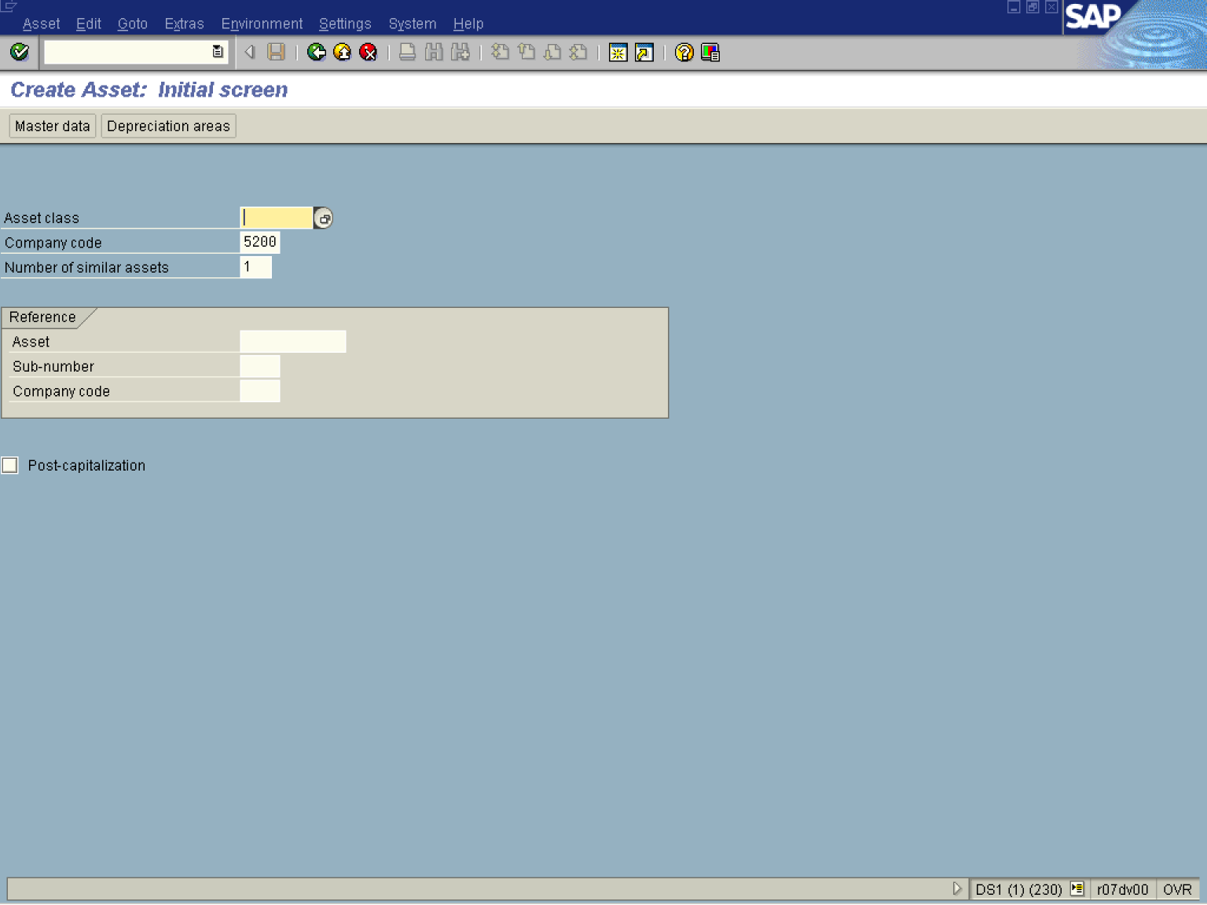

2. Press [F4] or Click the Search button in the Asset class field.
.

Restrict value range (1)

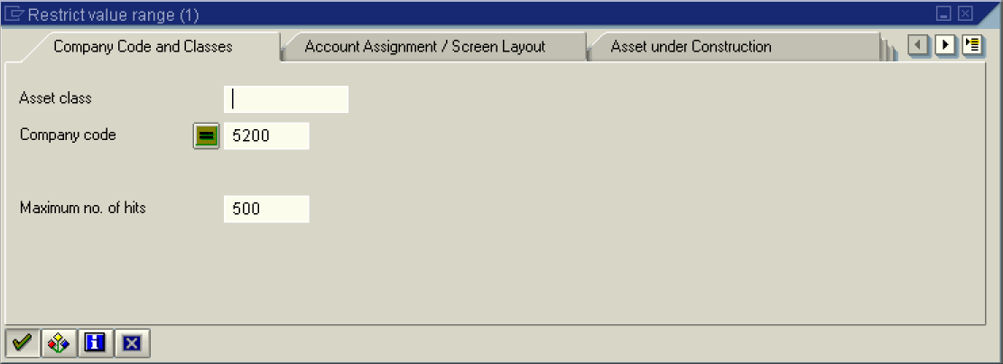
3. Click the Enter button for a complete list for company code 5200.
Restrict value range (1) 19 Entries found

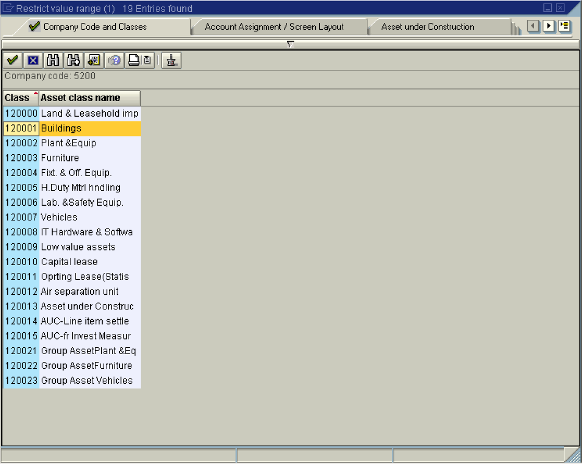

Note: A list of relevant documents is displayed based on your selection in the previous screen.
4. Select 120001 Buildings
5. Click Enter to confirm your entry.
Create Asset: Initial screen

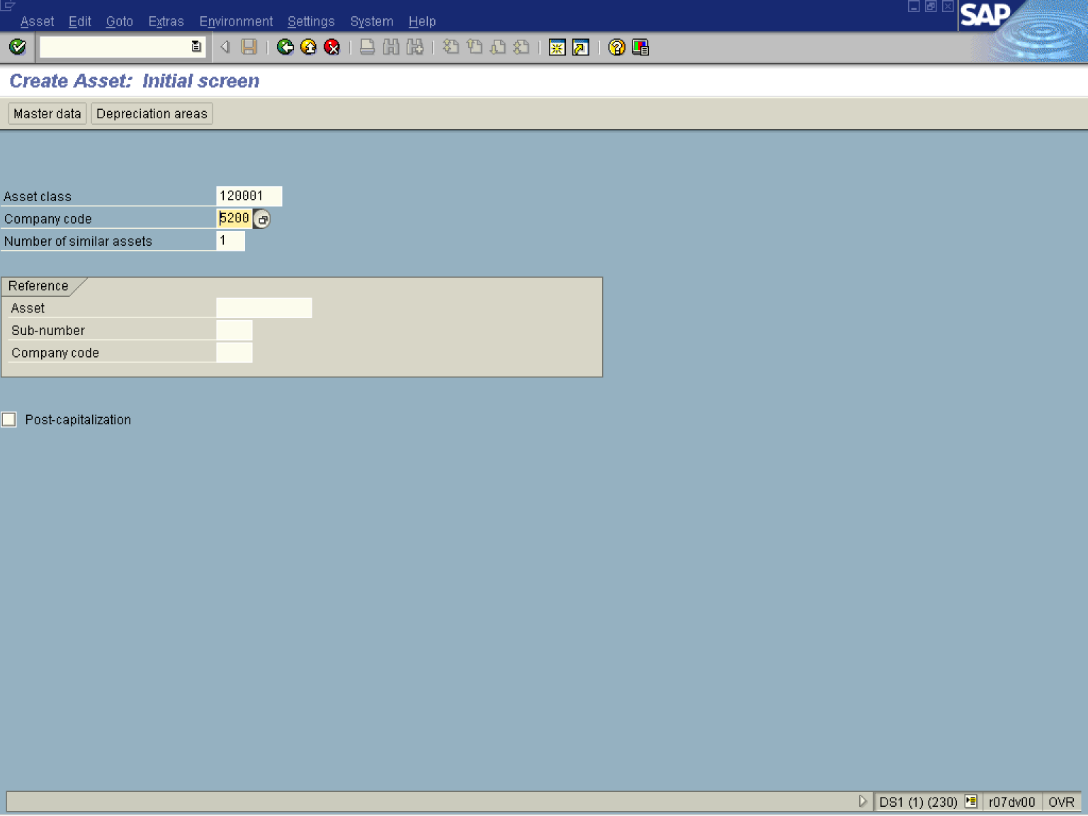

Note: Use the reference field if you'd like to create an asset master record that is similar to another asset master record. When creating a new asset with a reference asset, the values from the fields of the master record of the reference asset are proposed as default values.

Note: Number of similar assets; This function enables you to create multiple similar assets in one master transaction. These assets initially differ from each other only by their main and/or sub-number. When you save, you can also enter a description and inventory number for each individual master record.
This function does not allow you to create multiple assets that automatically have the same long text..
6. Click Master data Button .

Create Asset: Master data

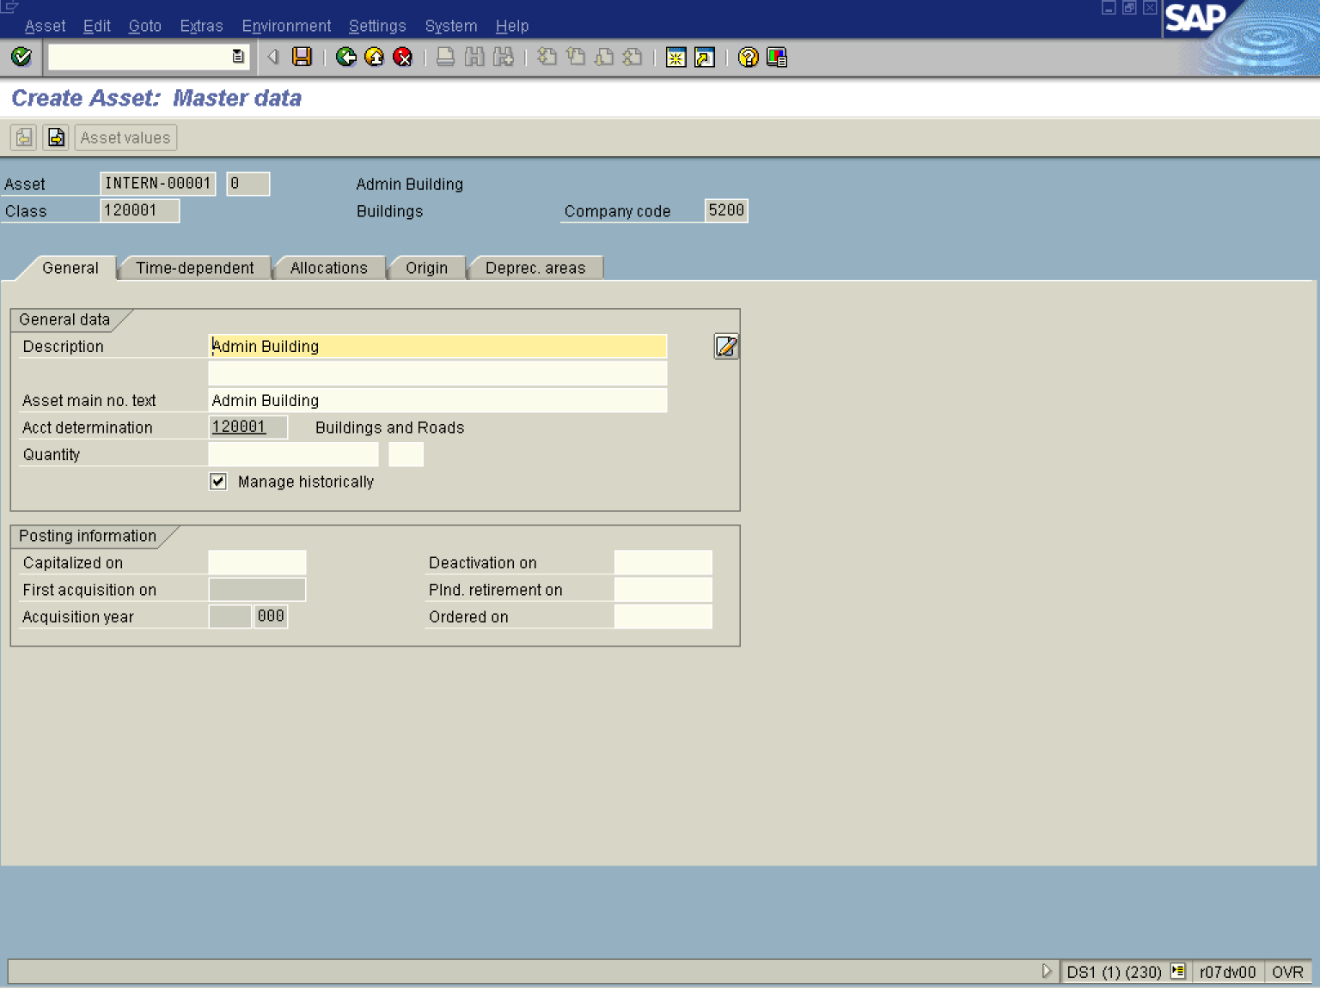

7. Update the following fields:

Field Name | Field Description | Values
Description | Enter a name for the asset in this field. | Example: Admin Building
Asset main no. text | In this field, you can enter any desired name for an asset main number. The text is then used, for example, in reporting, and in the display values transaction | Example: Admin Building

8. Click the Enter button to confirm your entries.
9. Click <tab button> Time-dependent .

Create Asset: Master data

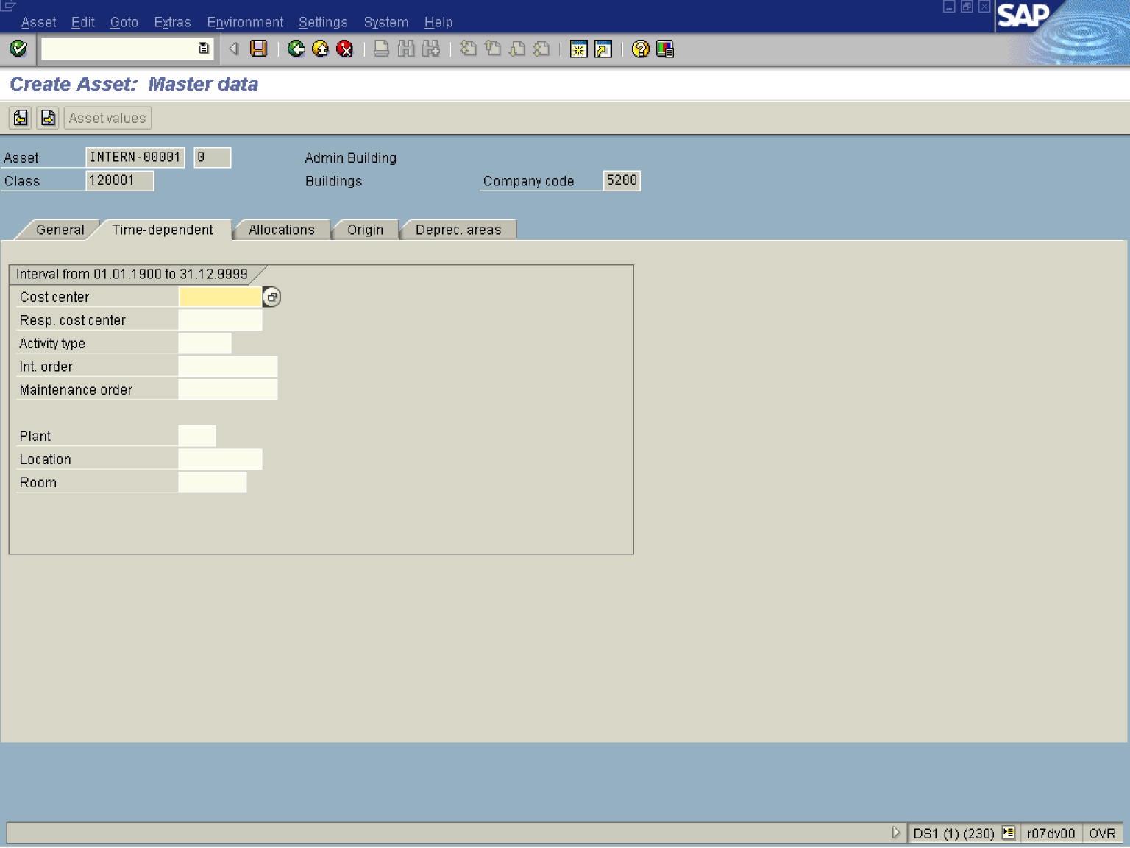
10. Press [F4] or Click the Search button in the Cost center field.

Restrict value range (1)

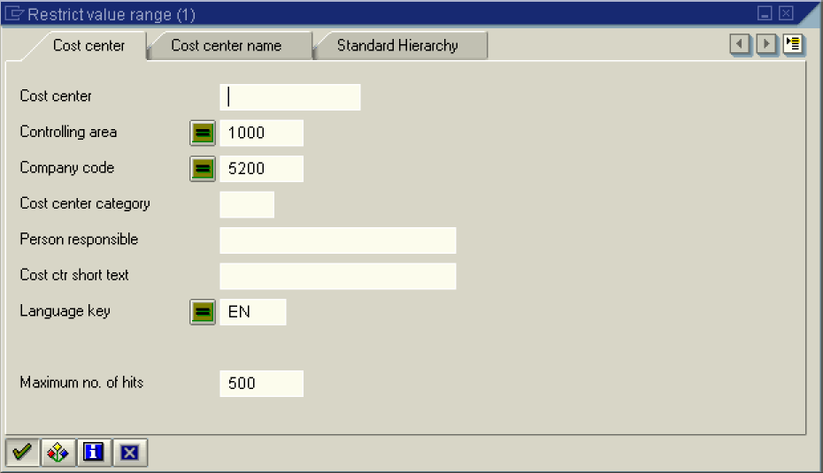

11. Click Enter Button 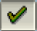 to get a list of cost centers based on your entries.

12. Select 5211000 - 1000 - 5200 - W - R. Pemberton - HUMAN RESOURCES - EN - 01.01.1900 - 31.12.2001 in list box.

13. Click the Enter button.

Create Asset: Master data

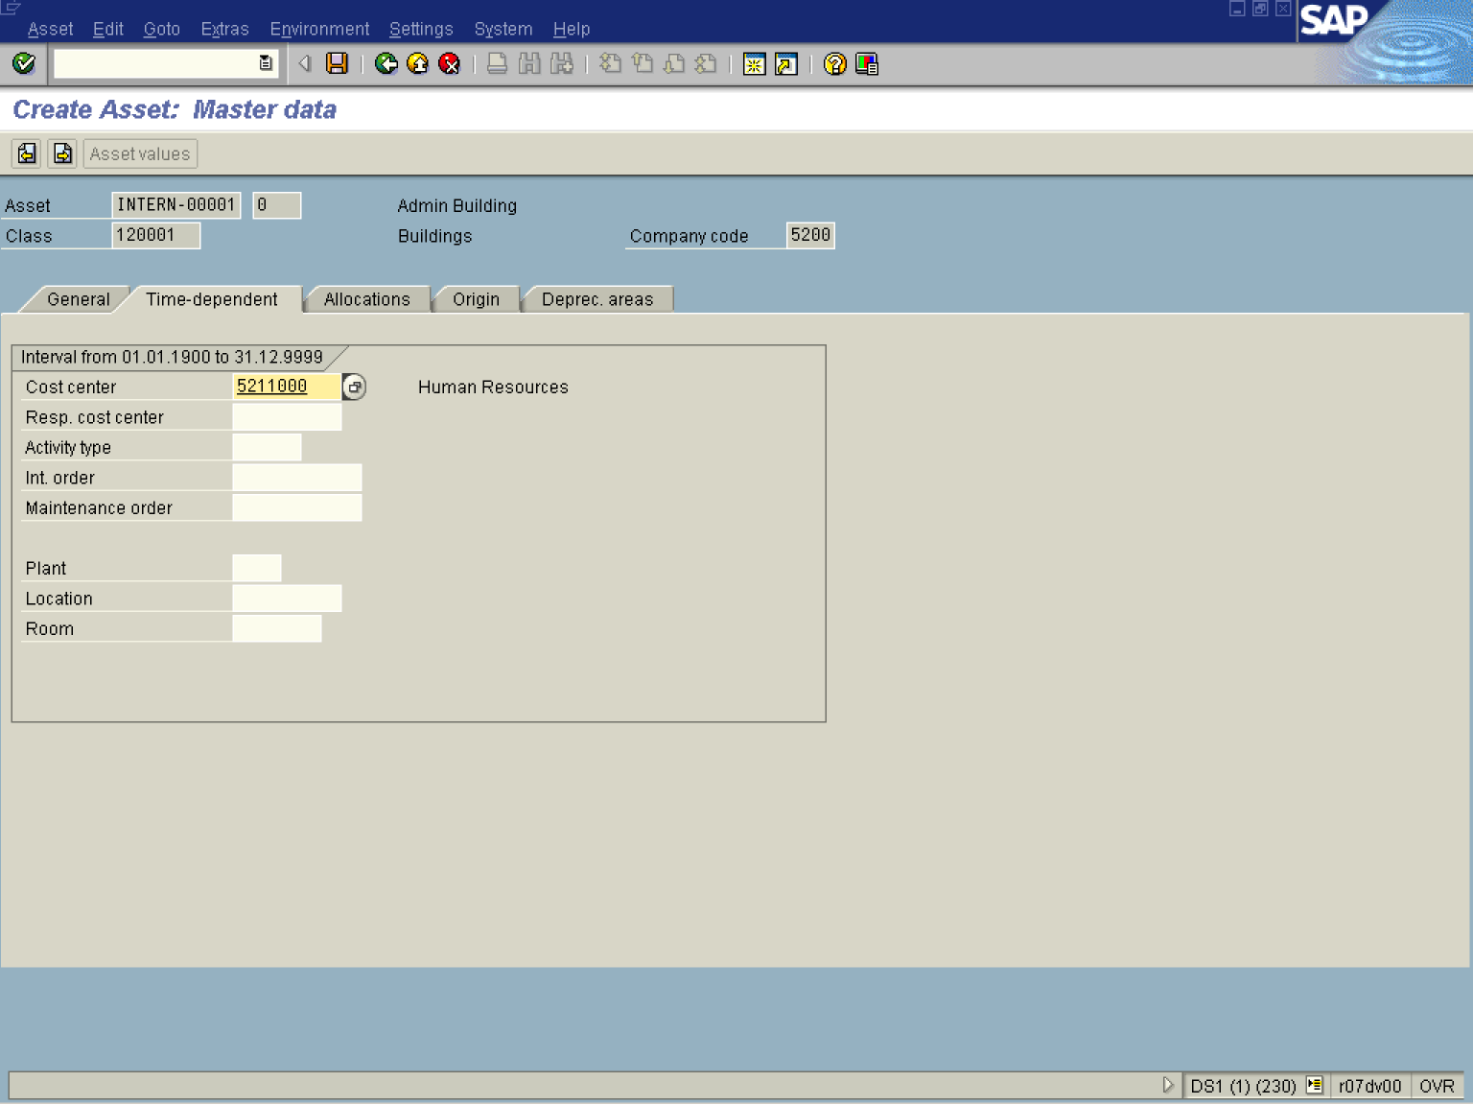

14. Click <tab button> Allocations .

Create Asset: Master data

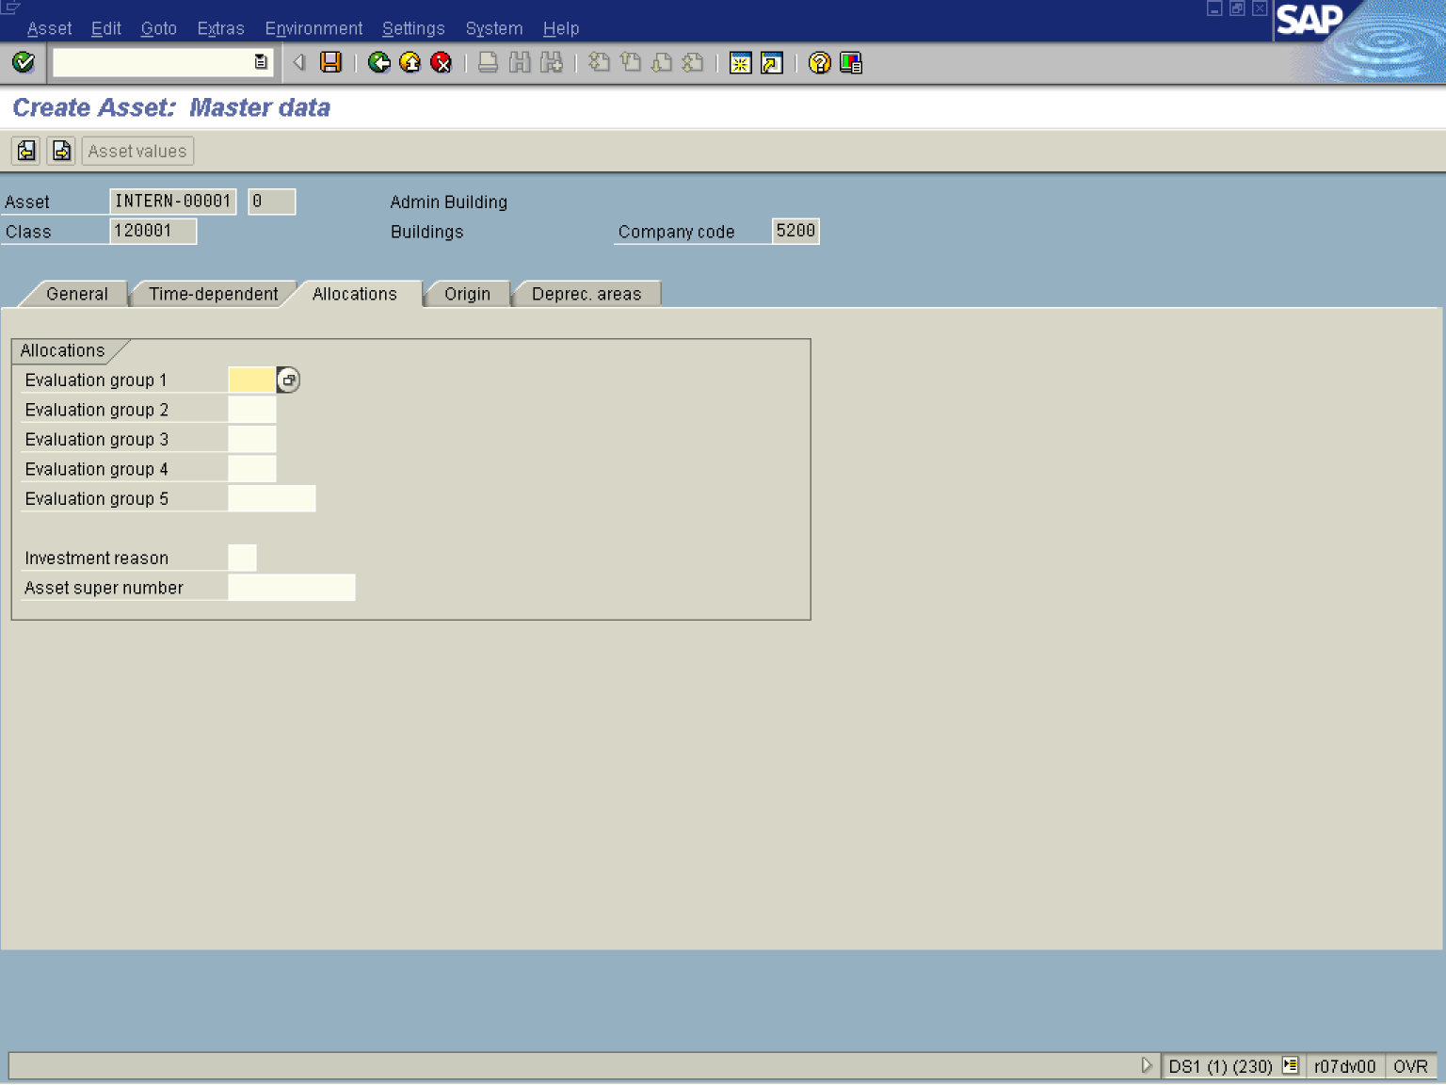

Note: Fields on this screen are typically used for report groupings as required.

15. Click <tab button> Origin Tab button for assignment to capital investment order.

Create Asset: Master data

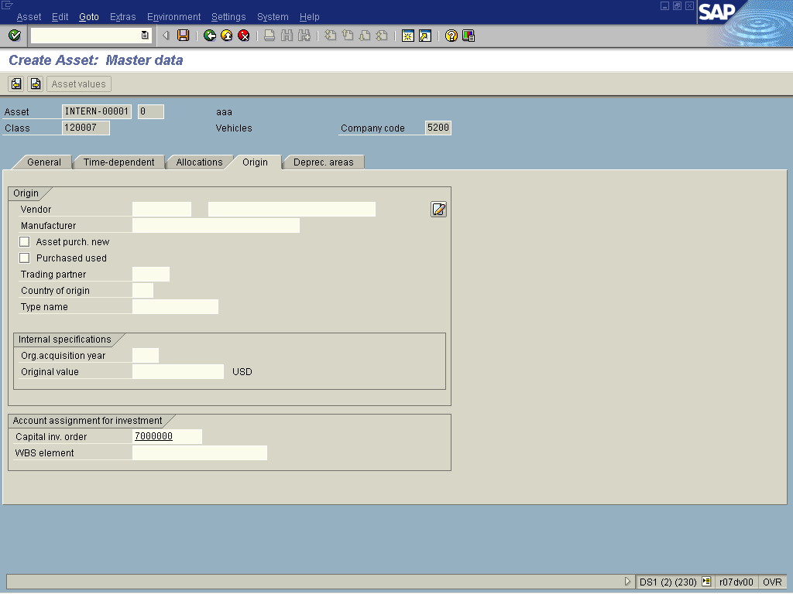

16. Update the following fields:

Field Name | Field Description | Values
Capital Inv. Order | Number of the internal order used for budgeting | Example: 7000000

17. Click <tab button> Deprec. areas

Create Asset: Master data

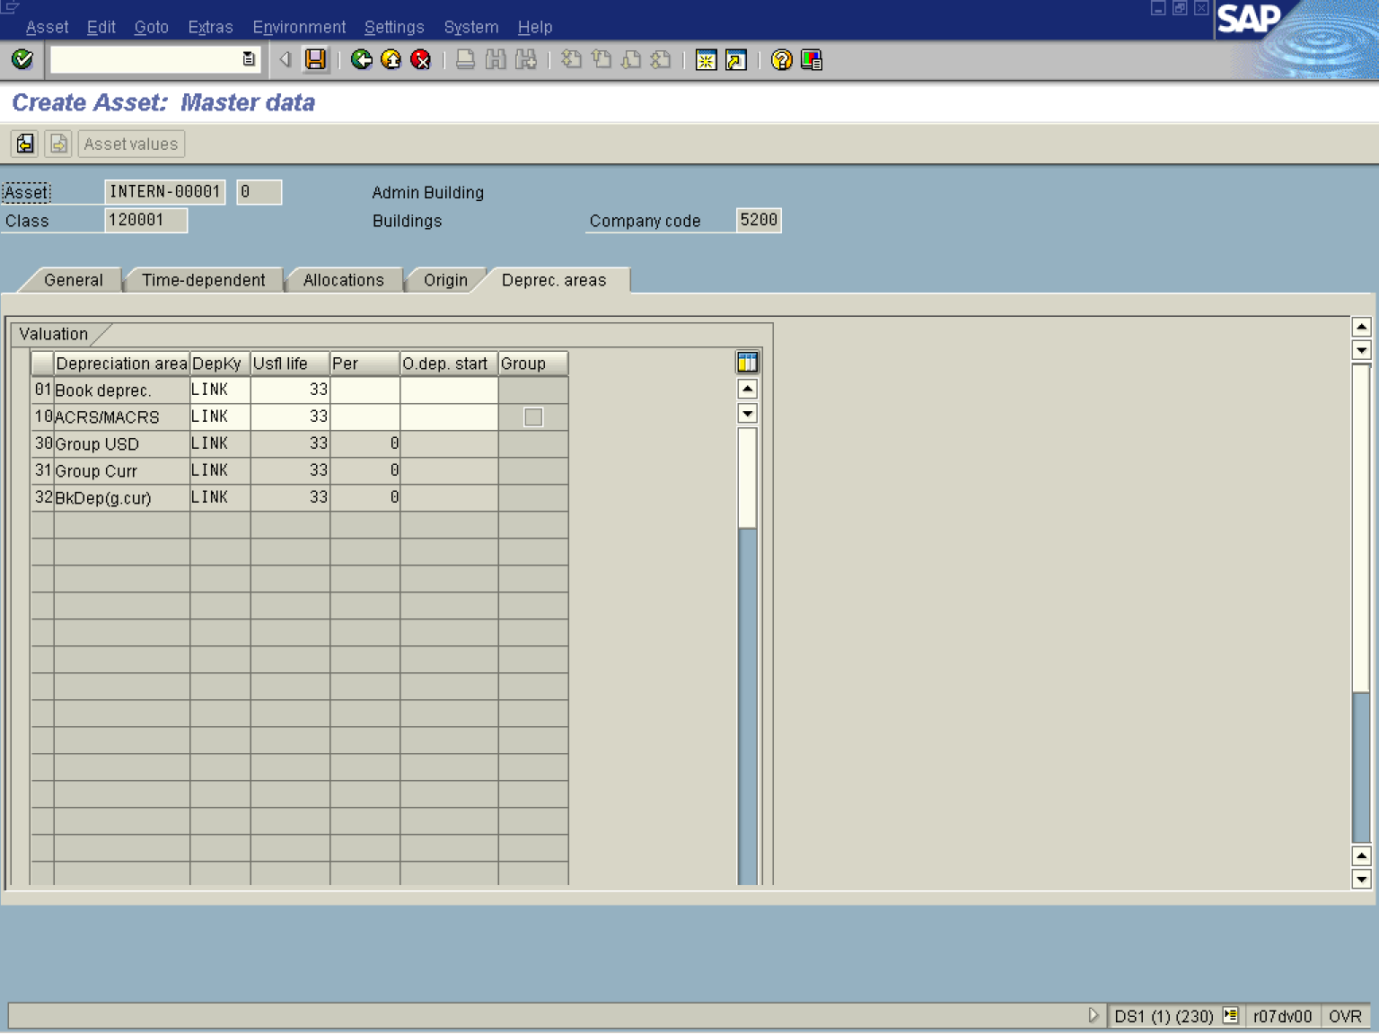

18. Update the following fields:

Field Name | Field Description | Values
DepKy | The depreciation key (valuation key) controls the valuation of the asset in the particular depreciation areas. | Example: LINK
Usfl life | Enter the useful life. | Example: 33
19. Click the Enter button to Validate the entries.
20. Click the Save button.

Create Asset: Initial screen

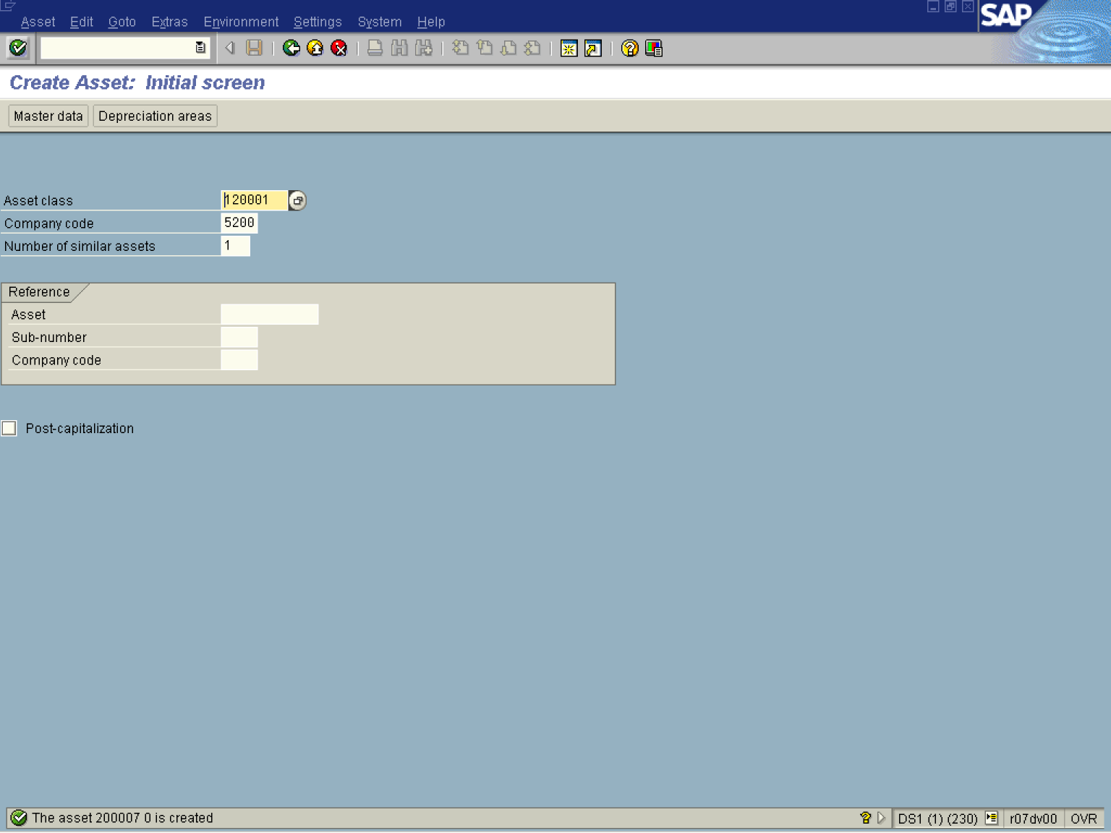

21. The message bar displays “The asset was created”

